**Github integration with Jenkins**

1.Go to Jenkins Dashboard

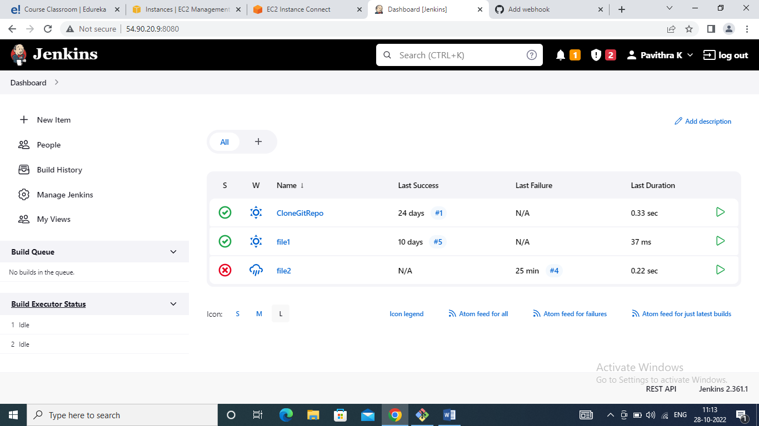

2.Create a Jenkins freestyle job with name and github_integration

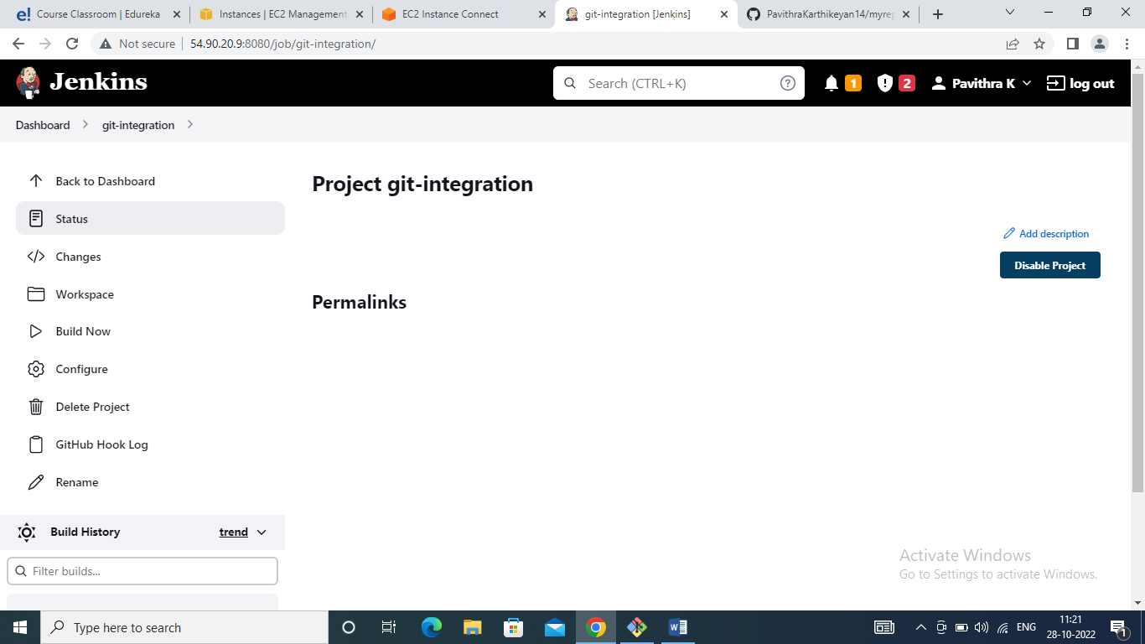

3.Add a GitHub repository to the job

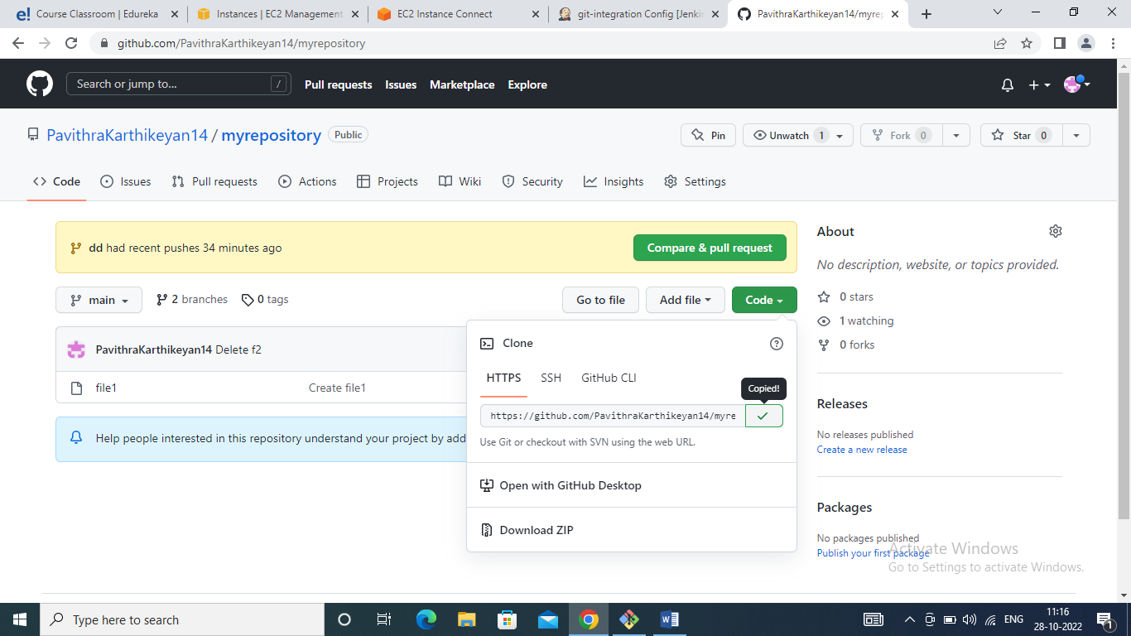

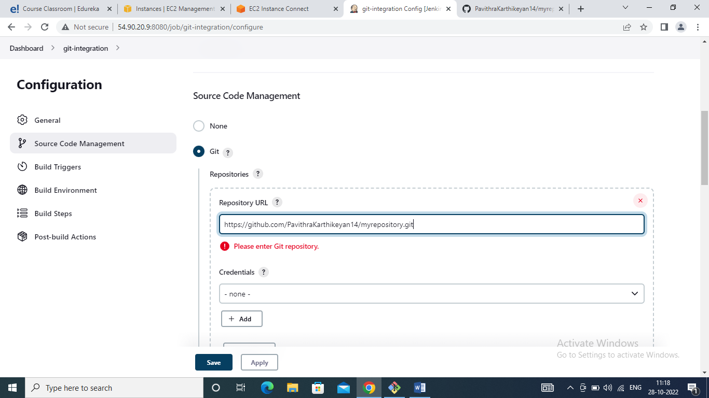

4.Add a trigger as a GitHub hook trigger for GITSCM polling

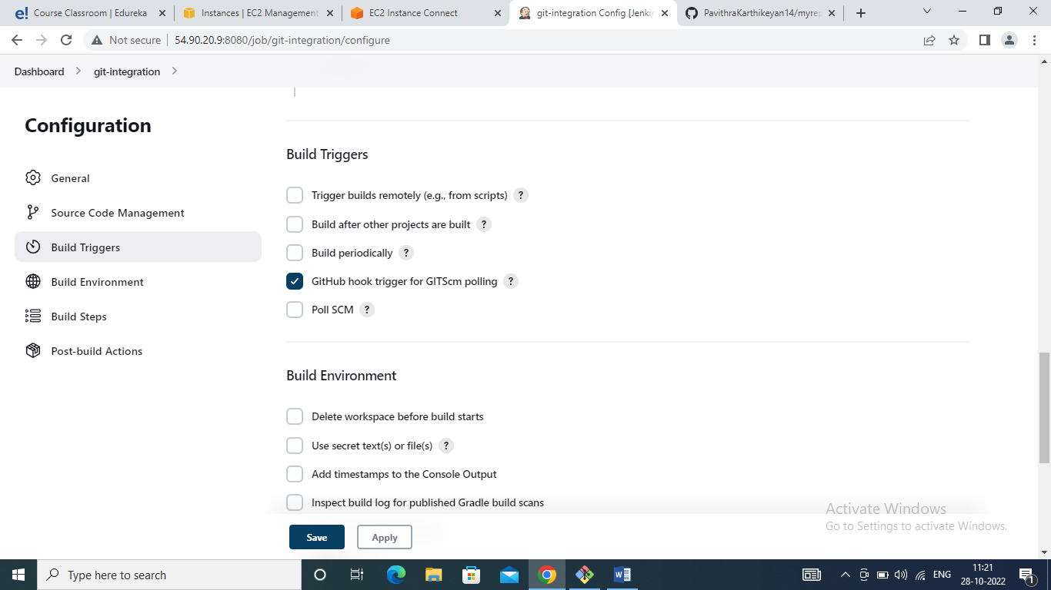

5.Go to the GitHub repository and add a webhook

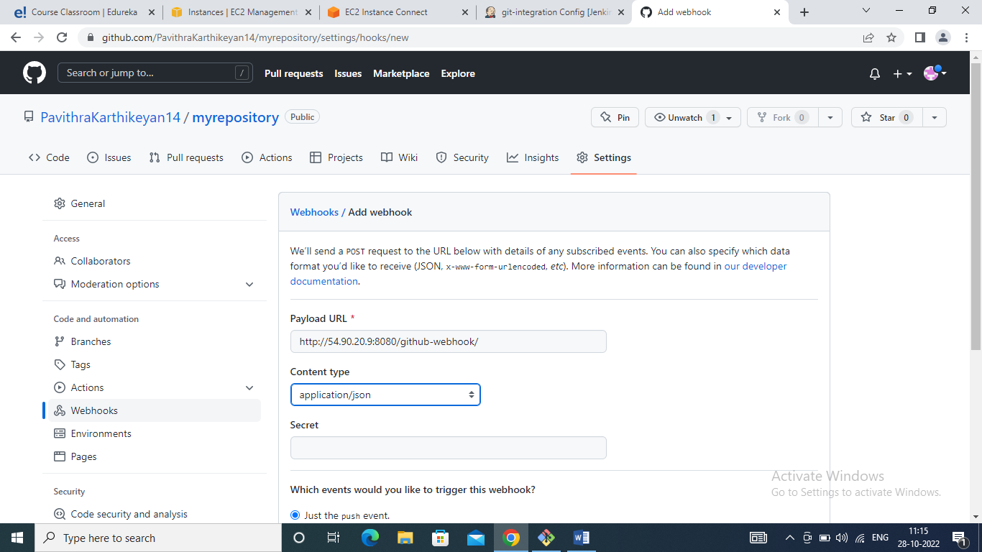

6.Commit changes in the repository and see if the build is triggered automatically or not.

